S-100 – Part 4b

Metadata for Imagery and Gridded Data
Summary of Substantive Changes in Edition 5.2.0

Change Summary | Clauses Effected
Part 4b – Metadata for Imagery and Gridded Data

Contents

4b-1 Scope 1
4b-2 Normative references 1
4b-2.1 Informative references 1
4b-3 Imagery and gridded data metadata 2
4b-3.1 Associated ISO standards 2
4b-3.2 Metadata packages 2
4b-3.2.1 Metadata Entity Set for Imagery 4
4b-3.2.2 Data quality information for Imagery 4
4b-3.2.3 Spatial representation information for Imagery 4
4b-3.2.4 Content information for Imagery 4
4b-3.2.5 Acquisition Information for Imagery 5
4b-4 UML diagrams and data dictionary 5

Page intentionally left blank

Scope
The general scope of parts 4a, 4b and 4c has been described at the beginning of part 4a. This part concerns itself specifically with the growing requirement to manage large volumes of imagery and gridded data which most hydrographic organizations have in addition to handling the vector data. There are many different imagery and gridded data formats and these types of datasets are often stored on distributed systems leading to problems of data discovery, management and exchange.
The production of imagery and gridded data follows the processes that usually begin with the collection of data, scanning of charts and reference documents, and other sensing methods. These types of datasets are often used for the production of paper charts, Electronic Navigational Charts (ENCs), Raster Navigational Charts, and nautical publications. Their production processes need to be documented in order to maintain quality control over the end products. Furthermore, metadata about the geometry of the measuring process and the properties of the measuring equipment needs to be retained with the raw data in order to support the production and maintenance processes.
This metadata Part of S-100 is based on ISO 19115-2:2009.

Normative references
The following referenced documents are indispensable for the application of this document. For dated references, only the edition cited applies. For undated references, the latest edition of the referenced document (including any amendments) applies.
ISO/TS 19103, Geographic information — Conceptual schema language
ISO 19107:2003, Geographic information — Spatial schema
ISO 19115-1:2018, Geographic information – Metadata – Part 1 – Fundamentals (published as ISO 19115-1:2014, amended by Amendment 1, 2018)
ISO 19115-2:2009, Geographic information - Metadata - Part 2: Extensions for imagery and gridded data
ISO 19119:2016, Geographic information – Services
ISO/TS 19115-3:2016, Geographic information - Metadata - XML schema implementation for fundamental concepts
ISO 19157:2018, Geographic information – Data Quality (published as ISO 19157:2013, amended by Amendment 1, 2018)
IHO S-61 Product Specification for Raster Navigational Charts

Informative references
The following references have been superseded by later editions or are otherwise useful though not normative:
ISO 19115:2005, Geographic information — Metadata
ISO/TS 19139, Geographic information — Metadata — XML schema implementation
ISO 19119:2005, Geographic information – Services

Imagery and gridded data metadata
ISO 19115-1 identifies the metadata required to describe digital geographic data, and the extensions described in this section identify the metadata required to describe digital geospatial imagery and gridded data. Digital geospatial imagery and gridded metadata may also be provided for aggregations of datasets.

Associated ISO standards
ISO 19115-1 is designed to be the general metadata standard applicable to all geographic data sets. It identifies a set of core metadata derived from the many metadata elements and also specifies the conditions under which they should be used (that is mandatory, conditional, or optional). Although there is some service metadata in ISO 19115-1, (particularly in the area of identification), much of the service metadata is defined in ISO 19119 (Services). ISO 19115 makes provision for limited metadata describing spatial and temporal Schemas.
ISO 19115-2 extends the metadata defined in ISO 19115 and identifies additional metadata (such as data quality, spatial representation, content, and acquisition information), required to describe imagery and gridded data. It provides information about the properties of the measuring equipment used to acquire data, geometry of the measuring processes employed by the equipment, and production processes used to digitize the raw data.
Geolocation information is a very important metadata component required for imagery. ISO 19115-1 and 19115-2 may not include sufficient geolocation metadata for imagery and gridded data. It may therefore be necessary to reference ISO 19130. This standard specifies additional information required to support geolocation and also defines how sensor measurements and geolocation information are logically associated. The georeferencing information in ISO 19130 is a subset of that described in ISO 19115-2. In order to develop a full set of imagery metadata, it may be necessary to combine the relevant sections from ISO 19115-1 and 19115-2, with the geolocation information or sensor properties from ISO 19130.
ISO 19115-3 - XML Schema implementation for fundamental concepts, expands ISO 19115-1 and 19115-2 by defining new constraint types that further refine the metadata elements for implementation. It also defines the rules used for deriving an XML Schema from the ISO abstract UML models.

Metadata packages
The relationships between the packages contained in ISO 19115-1 and the extensions for geospatial imagery and gridded data are illustrated in Figure 4b-1 below. Dependencies on other packages are also shown in the figure. ISO 19115-2 packages are shown with no fill, ISO 19115-1 packages with grey fill, and the others (ISO 19107 (Geometry), ISO 19157 (Data quality) and ISO 19103 (Conceptual Schema language)) in other colours. These metadata extensions have been fully documented using both UML models and a data dictionary, in ISO/TC211 19115–2 - Annex A and Annex B respectively.
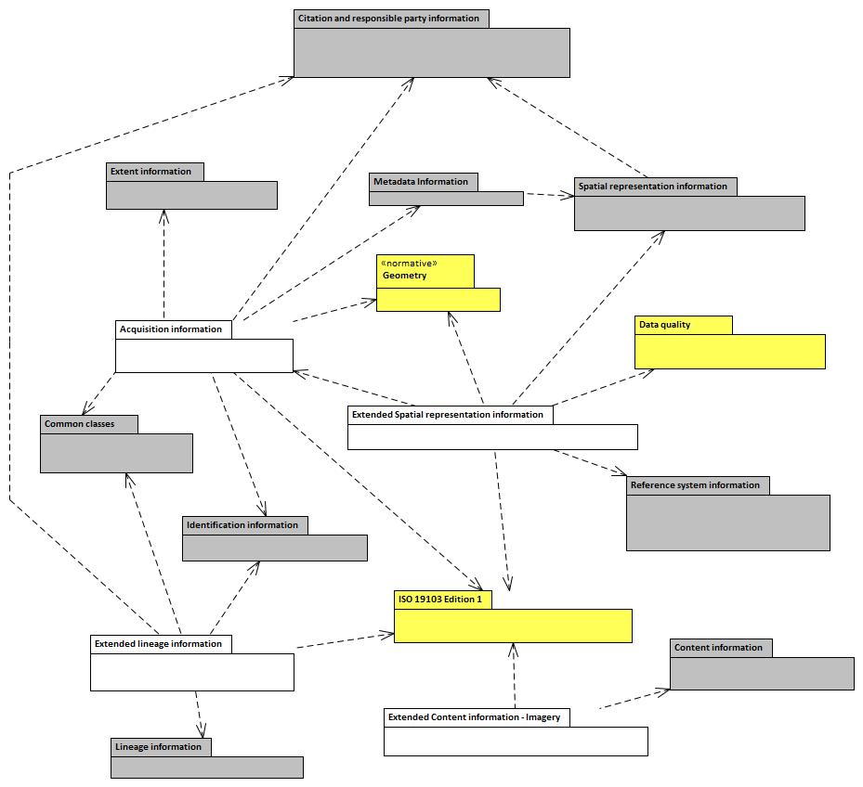
Figure 4b-1 — Metadata packages (from ISO 19115-2:2018)
It should also be noted that, to ensure global uniqueness, ISO/TS 19103 requires that all class names must be defined by a bi-alpha prefix that identifies the package to which a class belongs. The ISO 19115 series uses the prefixes MD (Metadata), CI (Citation), DQ (Data quality), EX (Extent), and LI (Lineage). To differentiate between classes used in ISO 19115-1 and those used in ISO 19115-2 (Extensions for imagery and gridded data), the MI prefix is used for imagery and gridded metadata, and LE and QE are used for extended Lineage and Data quality classes respectively. (Data quality classes are now defined in ISO 19157.) Table 4b-1 contains the list of package identifiers for the classes used for metadata.
Table 4b-1 —UML Package Identifiers
Identifier | Information Type | Standard
MD | Metadata | ISO 19115-1
MI | Metadata for Imagery | ISO 19115-2
DQ | Data Quality | ISO 19157
QE | Data quality Extended | ISO 19115-2
CI | Citation | ISO 19115-1
LI | Lineage | ISO 19115-1
LE | Lineage Extended for Imagery | ISO 19115-2
EX | Extent | ISO 19115-1
GM | Geometry | ISO 19107
MX | Metadata – XML Schema | ISO/TS 19139
PT | Polylinguistic Text | ISO/TS 19103
RS | Reference System | ISO 19115-1
SC | Spatial Coordinates | ISO 19111
SV | Metadata for services | ISO 19115-1

Metadata Entity Set for Imagery
MI_Metadata is a subclass of MD_Metadata which aggregates the optional entity MI_AcquisitionInformation. See sections A.2.1 and B.2.1 of ISO 19115-2 for additional descriptive information and the data dictionary respectively.

Data quality information for Imagery
Information about the sources and production processes used in producing an imagery or gridded dataset has been included in an additional Data Quality for Imagery package, as ISO 19115-1 only makes provision for a general assessment of the quality. The following additional classes are listed below. A more detailed description of the classes and associated data dictionary are provided in ISO 19115-2, sections A.2.2 and B.2.2 respectively, and ISO 19157.
- QE_CoverageResult is a specified subclass of DQ_Result and aggregates information required to report data quality for a coverage. It is based on concepts from ISO 19115 and ISO 19139.
- QE_Usability is a specified subclass of DQ_Element. It is intended to provide user specific.
- Quality information about a dataset’s suitability for a particular application.
- LE_ProcessStep is a specified subclass of LI_ProcessStep and contains additional information on the history of the algorithms used and processing performed to produce the data. LE_ProcessStep aggregates the following entities:
  - LE_Processing, describes the procedure (such as software used, parameters, and processing documentation) by which the algorithm was applied to generate the data from the source data. LE_Processing aggregates LE_Algorithm, which describes the methodology used to derive the data from the source data;
  - LE_ProcessStepReport identifies external information describing the processing of the data;
  - LE_Source is a specified subclass of LI_Source and describes the output of a process step.

Spatial representation information for Imagery
This package contains information concerning the mechanisms used to represent spatial information. This package defines the following entities:
- MI_Georectified contains check point information to further specify georectification details of the imagery or gridded data. It aggregates MI_GCP;
- MI_Georeferenceable makes provision for the inclusion of additional information that can be used to geolocate the data. It aggregates MI_GeolocationInformation.

Content information for Imagery
Although this package is part of ISO 19115-1, the following entities have been included to better cater for imagery and gridded data:
- MI_Band (subclass of MD_Band) - defines additional attributes for specifying properties of individual wavelength bands in an imagery and gridded dataset;
- MI_ImageDescription (subclass of MD_ImageDescription) - used to aggregate MI_RangeElementDescription;
- MI_CoverageDescription (subclass of MD_CoverageDescription) - used to aggregate MI_RangeElementDescription;
- MI_RangeElementDescription - used to provide range elements used in a coverage dataset.

Acquisition Information for Imagery
MI_AcquisitionInformation is an aggregate of the following entities:
- MI_Instrument (the measuring instruments used to acquire the data);
- MI_Operation,(the overall data gathering program to which the data contribute);
- MI_Platform (the platform from which the data were taken);
- MI_Objective (the characteristics and geometry of the intended object to be observed);
- MI_Requirement (the user requirements used to derive the acquisition plan);
- MI_Plan (the acquisition plan that was implemented to acquire the data).
Two additional classes are required to provide information on the acquisition of the data. These are:
- MI_Event describes a significant event that occurred during data acquisition. An event can be associated with an operation, objective, or platform pass; and
- MI_PlatformPass identifies a particular pass made by the platform during data acquisition. A platform pass is used to provide supporting identifying information for an event and for data acquisition of a particular objective.

UML diagrams and data dictionary
The metadata Schemas for the imagery and gridded data are included in ISO 19115–2 (Annex A) in the form of UML class diagrams. These diagrams augment the UML diagrams shown in ISO 19115-1.
ISO 19115–2, Annex B contains the element and entity definitions for the metadata Schemas defined in Annex A. The dictionary, in conjunction with the diagrams presented in Annex A and in combination with the UML diagrams and data dictionary presented in ISO 19115-1, serves to fully define the total abstract model for metadata.
Enumerations and their values provided in ISO 19115-1 are normative. User extensions to enumerations shall follow the rules as described in ISO 19115-1 and Annex 4a-E of S-100.

Page intentionally left blank

